Hello Tillicum families!

We are excited to now offer an online payment option for the Nutritional Snack Program! If you have already registered your child with School CashOnline you will see it as a new payment option before the start of each month. See directions below if you have not already registered.
If you choose to use the online payment option, you do not need to return the paper slip to the school. If you prefer cash or cheque payments, please continue to return the slips and envelopes that your student brings home, being sure to include your child's name and teacher or division.

We encourage you to contribute your fair share so we can continue the snack program here at Tillicum Community School.

To set up an account and explore the system follow the links below;
Step 1) Please go to our school website https://tillicum.sd61.bc.ca/ and click on the School Cash Online button
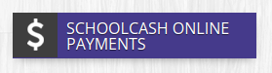
Step 2) Click Register and follow the steps.
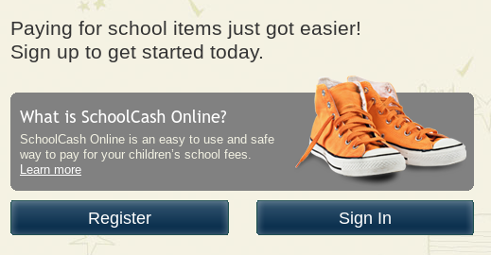

Step 3) Wait for the confirmation email, follow the steps to register each child on your household's account. If you have any questions please select the support button on the bottom right of the website.

Thank you for your support,
Melissa Smith
School Meal Assistant

